Full stack

Definition
# Source: AI Source: Provided by: [Data Path: Persons Table -> ID Column: 1, Name_En Column: Motasem Essam] -> From: [ChatGPT] on [1/26/2026]
Full stack usually means both the front end and the back end of a software application — especially in web development.
Here’s a simple breakdown:

Front end (what users see)
# Source: AI Source: Provided by: [Data Path: Persons Table -> ID Column: 1, Name_En Column: Motasem Essam] -> From: [ChatGPT] on [1/26/2026]
This is the visual part of a website or app.
- Layout, buttons, colors, animations
- Built with: HTML, CSS, JavaScript
- Popular tools: React, Angular, Vue

Back end (server + logic)
# Source: AI Source: Provided by: [Data Path: Persons Table -> ID Column: 1, Name_En Column: Motasem Essam] -> From: [ChatGPT] on [1/26/2026]
This is the behind-the-scenes part that users don’t see.
- Handles data, login, security, business logic
- Communicates with databases
- Built with: Node.js, Python, Java, PHP, .NET, etc.

Database (data storage)
# Source: AI Source: Provided by: [Data Path: Persons Table -> ID Column: 1, Name_En Column: Motasem Essam] -> From: [ChatGPT] on [1/26/2026]
Where app data is stored.
- Examples: MySQL, PostgreSQL, MongoDB

Full Stack Developer

Definition
# Source: AI Source: Provided by: [Data Path: Persons Table -> ID Column: 1, Name_En Column: Motasem Essam] -> From: [ChatGPT] on [1/26/2026]
A Full-Stack Developer is a software developer who can work on both the front-end and back-end of applications or websites. They handle everything from designing the user interface to building server-side logic and managing databases.

A full stack developer can work on:
- Front end +
- Back end +
- Database +
- Sometimes deployment (servers, cloud, DevOps)
They can build a complete application from start to finish.

Simple Definition
# Source: AI Source: Provided by: [Data Path: Persons Table -> ID Column: 1, Name_En Column: Motasem Essam] -> From: [ChatGPT] on [1/26/2026]
Full-Stack Developer = a developer who builds both the user-facing part (front-end) and the server/data part (back-end) of a software application.

Key Responsibilities of a Full-Stack Developer
# Source: AI Source: Provided by: [Data Path: Persons Table -> ID Column: 1, Name_En Column: Motasem Essam] -> From: [ChatGPT] on [1/26/2026]
- Front-End Development
  - Build responsive user interfaces (UI)
  - Implement interactive features using HTML, CSS, JavaScript, and frameworks like React or Angular
- Back-End Development
  - Develop server-side logic and APIs
  - Work with databases (MySQL, MongoDB, PostgreSQL) to store and retrieve data
- Integration of Front-End and Back-End
  - Ensure smooth communication between the UI and server
  - Connect front-end requests to back-end responses
- Database Management
  - Design, query, and maintain databases
  - Ensure data integrity and security
- Testing and Debugging
  - Test both front-end and back-end for bugs and performance issues
  - Optimize applications for speed and reliability
- Deployment and Maintenance
  - Deploy applications to servers or cloud platforms
  - Maintain and update full-stack applications
- Collaboration
  - Work with designers, other developers, and stakeholders
  - Handle the entire development workflow if needed

Skills a Full-Stack Developer Usually Needs

1. Front-End / User Interface Skills
# Source: AI Source: Provided by: [Data Path: Persons Table -> ID Column: 1, Name_En Column: Motasem Essam] -> From: [ChatGPT] on [1/26/2026]
- Building user interfaces for web, desktop, mobile, or game platforms
- Tools / Languages:
  - UI Languages: HTML, CSS, JavaScript (for web)
  - Mobile UI: Swift, Kotlin, React Native, Flutter
  - Desktop UI / GUI: C# (WPF), JavaFX, Qt, Electron
  - Game UI / Graphics: Unity (C#), Unreal Engine (C++/Blueprints), Godot (GDScript)
- Responsive and adaptive design for different screens and devices

2. Back-End / Logic Skills
# Source: AI Source: Provided by: [Data Path: Persons Table -> ID Column: 1, Name_En Column: Motasem Essam] -> From: [ChatGPT] on [1/26/2026]
- Developing server-side or system-side logic for applications across platforms
- Tools / Languages:
  - Node.js, Python, Java, PHP, C#, C++, Ruby
  - Frameworks: Django, Spring Boot, Express.js, Laravel
  - Game or simulation logic engines: Unity, Unreal, Godot
- Implementing business rules, calculations, authentication, and workflow logic

3. Databases / Data Management
# Source: AI Source: Provided by: [Data Path: Persons Table -> ID Column: 1, Name_En Column: Motasem Essam] -> From: [ChatGPT] on [1/26/2026]
- Storing, retrieving, and managing data in different types of applications
- Databases: MySQL, PostgreSQL, MongoDB, Redis, SQLite
- Knowledge of SQL, NoSQL, or embedded databases for IoT or desktop apps

4. APIs / Services / Communication
# Source: AI Source: Provided by: [Data Path: Persons Table -> ID Column: 1, Name_En Column: Motasem Essam] -> From: [ChatGPT] on [1/26/2026]
- Designing or consuming interfaces for data exchange and integration
- Examples: REST, GraphQL, WebSocket, gRPC, MQTT (IoT)

5. Version Control, Deployment & DevOps
# Source: AI Source: Provided by: [Data Path: Persons Table -> ID Column: 1, Name_En Column: Motasem Essam] -> From: [ChatGPT] on [1/26/2026]
- Tracking code changes and collaboration: Git, GitHub, GitLab
- Deployment and containerization: Docker, Kubernetes, CI/CD pipelines
- Cloud and server platforms: AWS, Azure, GCP
- Cross-platform builds: mobile app stores, desktop installers, cloud services

6. Soft Skills
# Source: AI Source: Provided by: [Data Path: Persons Table -> ID Column: 1, Name_En Column: Motasem Essam] -> From: [ChatGPT] on [1/26/2026]
- Problem-solving and analytical thinking
- Communication and collaboration with cross-functional teams
- Adaptability to work across different platforms and technologies
- Time management and multitasking

Example Tasks of a Full-Stack Developer
# Source: AI Source: Provided by: [Data Path: Persons Table -> ID Column: 1, Name_En Column: Motasem Essam] -> From: [ChatGPT] on [1/26/2026]
- Build a complete e-commerce application: product pages, shopping cart, payment processing, and admin dashboard
- Create a social media platform: posts, comments, user authentication, and notifications
- Develop a mobile + web app: API for backend + interactive front-end interface

Comparison of Developers Across All Platforms
# Source: AI Source: Provided by: [Data Path: Persons Table -> ID Column: 1, Name_En Column: Motasem Essam] -> From: [ChatGPT] on [1/26/2026]
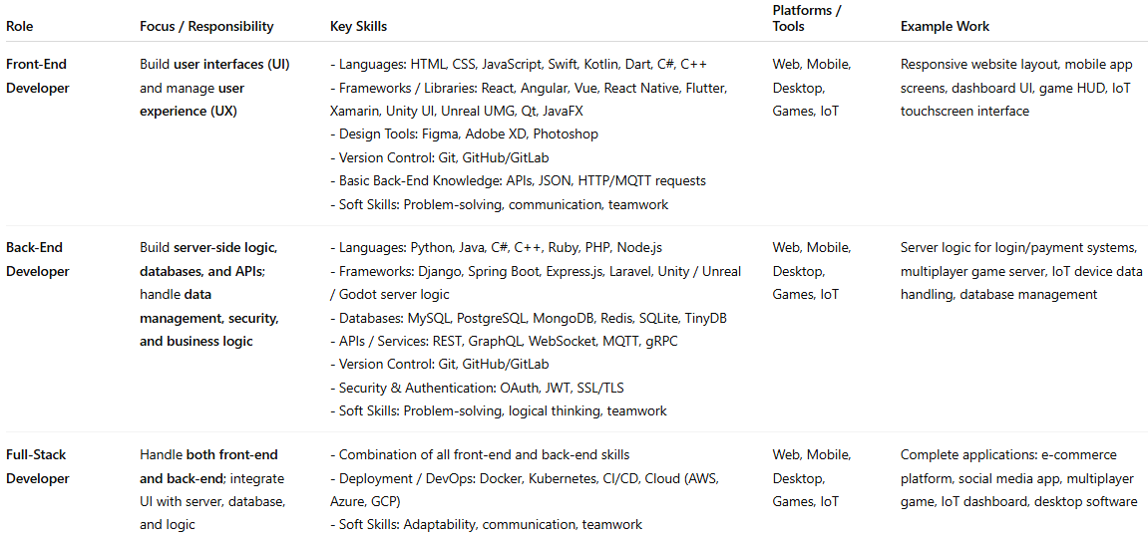
Role | Focus / Responsibility | Key Skills | Platforms / Tools | Example Work
Front-End Developer | Build user interfaces (UI) and manage user experience (UX) | - Languages: HTML, CSS, JavaScript, Swift, Kotlin, Dart, C#, C++ - Frameworks / Libraries: React, Angular, Vue, React Native, Flutter, Xamarin, Unity UI, Unreal UMG, Qt, JavaFX - Design Tools: Figma, Adobe XD, Photoshop - Version Control: Git, GitHub/GitLab - Basic Back-End Knowledge: APIs, JSON, HTTP/MQTT requests - Soft Skills: Problem-solving, communication, teamwork | Web, Mobile, Desktop, Games, IoT | Responsive website layout, mobile app screens, dashboard UI, game HUD, IoT touchscreen interface
Back-End Developer | Build server-side logic, databases, and APIs; handle data management, security, and business logic | - Languages: Python, Java, C#, C++, Ruby, PHP, Node.js - Frameworks: Django, Spring Boot, Express.js, Laravel, Unity / Unreal / Godot server logic - Databases: MySQL, PostgreSQL, MongoDB, Redis, SQLite, TinyDB - APIs / Services: REST, GraphQL, WebSocket, MQTT, gRPC - Version Control: Git, GitHub/GitLab - Security & Authentication: OAuth, JWT, SSL/TLS - Soft Skills: Problem-solving, logical thinking, teamwork | Web, Mobile, Desktop, Games, IoT | Server logic for login/payment systems, multiplayer game server, IoT device data handling, database management
Full-Stack Developer | Handle both front-end and back-end; integrate UI with server, database, and logic | - Combination of all front-end and back-end skills - Deployment / DevOps: Docker, Kubernetes, CI/CD, Cloud (AWS, Azure, GCP) - Soft Skills: Adaptability, communication, teamwork | Web, Mobile, Desktop, Games, IoT | Complete applications: e-commerce platform, social media app, multiplayer game, IoT dashboard, desktop software

- Maintain database performance for a high-traffic website

